SUMMER INTERNSHIP REPORT



NAME: DAVID NALLAPU

COLLEGE: SHIV NADAR UNIVERSITY

EMPLOYEE ID: 1216733

TEAM: GOLF

**OBJECTIVE**: To make a web-app that shows statistics of Sales Order data and to predict the chance of failure in a particular ASN.

**SOLUTION**: Created a web-app that is connected to the Golf database. The web-app gets required data from the database and displays it. Prediction of failure was done with machine learning.

**TECH STACK**: Angular, Spring Boot, Python(Machine Learning),Typescript

**FRAMEWORK**: Angular

**LEARNINGS:**

|  |  |
| --- | --- |
| WEEK 1 | Started Learning Angular |
| WEEK 2 | Continued Learning Angular |
| WEEK 3 | Started Learning Spring Boot |
| WEEK 4 | Started Learning Oracle SQL integration with Spring Boot |
| WEEK 5 | Learnt to integrate Spring Boot with Angular for GET requests |
| WEEK 6 | Created GET requests for data retrieval from GOLF database to plot 3PL locations on map |
| WEEK 7 | Connected Python ML script to Angular and Spring Boot |
| WEEK 8 | Preprocessing of data and application of ML model |

**USAGE:** 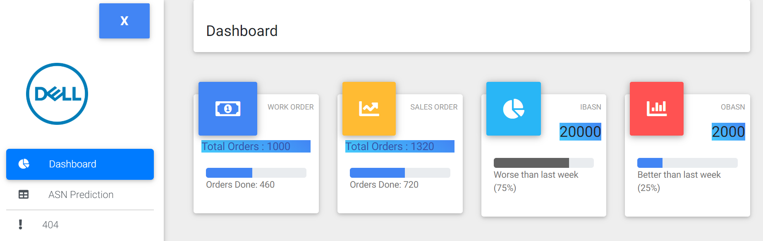

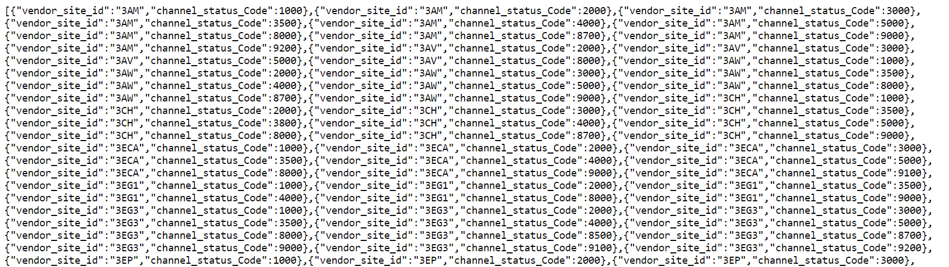

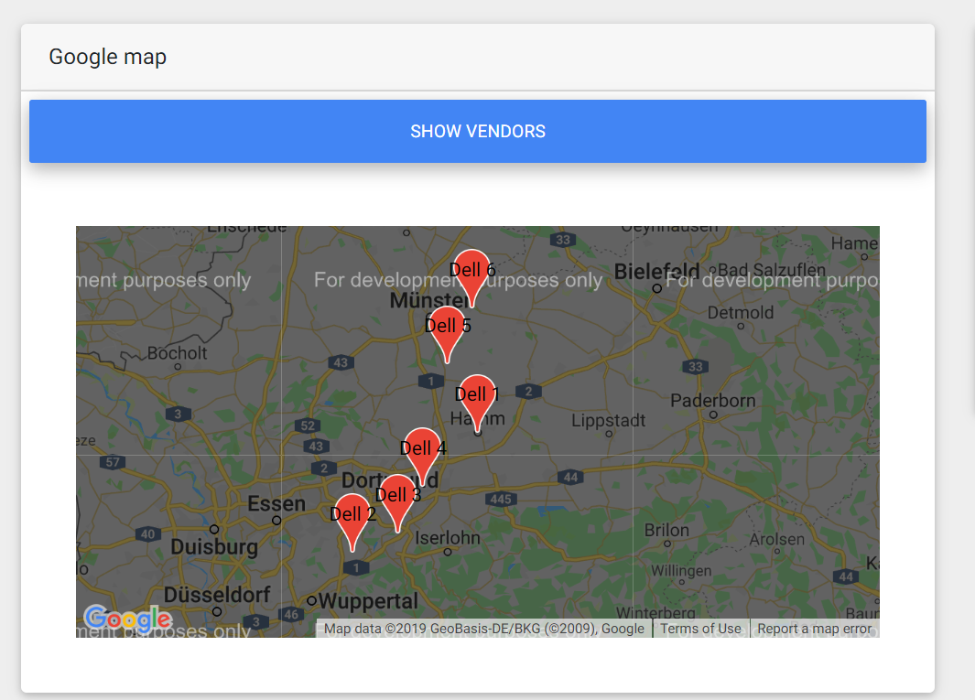

**CONCLUSION**: During this internship I learnt some completely new concepts and languages, working on Angular was a whole new experience for me. I had never learnt web development before but now I can confidently have a client and server running simultaneously along with data from a database. It helped me understand the importance of web development. I also understood the functionalities of REST APIs. I also got a chance to implement some data analysis and machine learning on the data. I wasn’t completely successful in the ML part but I learnt a lot on applying ML in logistics.

**BIBLIOGRAPHY:**

Resources: Udemy, LinkedIn Learning, online tutorials and stack overflow.

Special Thanks to: B. Radhabai, Sabbi Thirumala, and the complete GOLF Team.